Calgary

Lost ring missing for 37 years in Calgary has been reunited with its owner

Teacher Evan Cappon felt it was worth following the clues on the 1972 nursing class ring
CBC News · Posted: Sep 26, 2020 10:46 AM MT | Last Updated: September 26
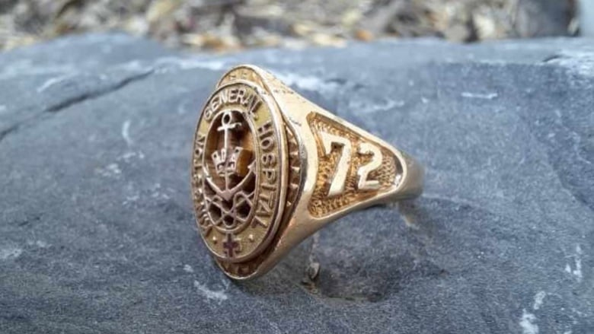
This 1972 grad ring was found by teacher Evan Cappon on the grounds of Master's Academy in southwest Calgary. He spent three months tracking down its owner, a member of the Kingston General Hospital's school of nursing. (Evan Cappon)

In the middle of the COVID-19 lockdown, Grade 5 teacher Evan Cappon was bored. So one day, he decided to take his metal detector to school with him at Master's Academy in southwest Calgary.
That day, he found a ring — and it launched him into a three-month-long quest.
"I was outside the front doors and 'ping' — a sound comes up, and I'm like, oh, it's going to be tinfoil," Cappon told the the Calgary Eyeopener. "Well, I dug it up, and lo and behold it's shown to be a gold ring."
It was a grad ring from the class of 1972 at Kingston General Hospital's school of nursing in Kingston, Ont.
"So I pulled it up, took a look at it and I was like, OK, this is a rather interesting find," Cappon said.
Cappon thought the ring had enough markings on it that meant if he could find enough information, he could find the owner. So, he started looking around.
He started by calling the hospital itself in Kingston. Someone there put him in touch with a museum of medicine, which led him to a class yearbook.
"I got ahold of one of the alumni members, and she passed me on to the class rep. The class rep that got me the class list that she had, which was about 150 people long," he said. "I tried looking at Facebook, that didn't work."
Meanwhile, the class rep offered to ask around within her friend group.
And that's how they found that one of their nursing graduates had lost a class ring in Calgary.

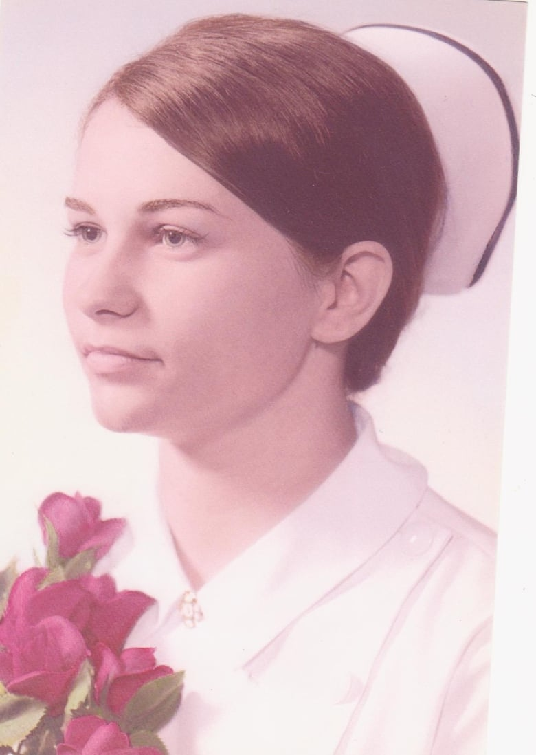
Nursing graduate Joy Malcolm, class of 1972 in the Kingston General Hospital's school of nursing. (Submitted by Joy Malcolm)
That person was Joy Malcolm, who now lives in Ottawa. She was surprised to hear that Cappon had spent three months tracking her down.
"Well, it was pretty astounding wasn't it, to track down a person who doesn't even live in Calgary anymore or who doesn't live in Kingston, and to go to all that work to to find a complete stranger just to make their day," Malcolm said.
Cappon said he was happy to have solved the mystery.
"Well, that's the fun of it. I really love doing that," Cappon said. "And just to know that I got it back to her is kind of just puts a real smile on my face and a real sense of satisfaction."
Malcolm said she'd never expected to see the ring again.
"Well, I think all grad rings are sentimental — you don't just walk into any jewelry store and buy it, it's something you earn. So it means a lot," she said. "Because you earned this thing. So, you know, when you lose it, you're kind of devastated."
The ring was lost by Malcolm's son, when he decided to take it to school one day in Calgary.
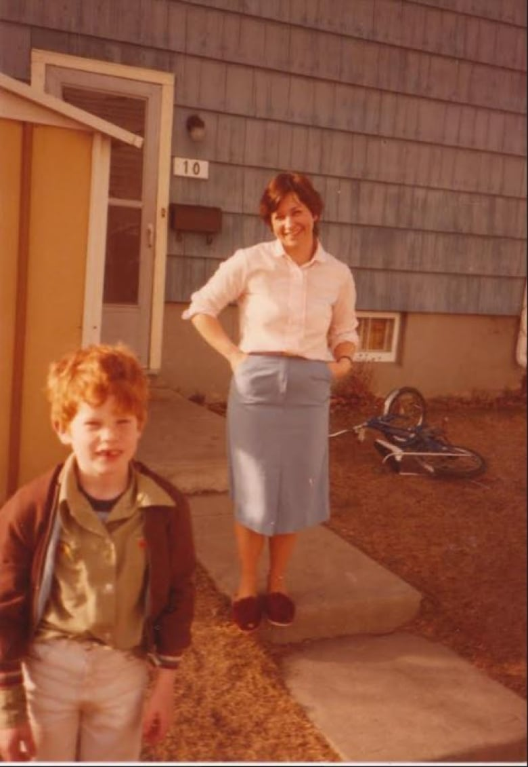
Joy Malcolm and her son Chris in Calgary, around the time the ring went missing. Malcolm says she was happy to inform her son that the ring has been found, 37 years later. (Submitted by Joy Malcolm)
"My son was young at the time, maybe six or seven, and I guess he was just being a kid. I have no idea why he picked it up," Malcolm said. "I don't think he knows. He picked it up and put it in his pocket and went off to school. And that's how we knew we had lost it at the school, or on the route to the school, or the route home."
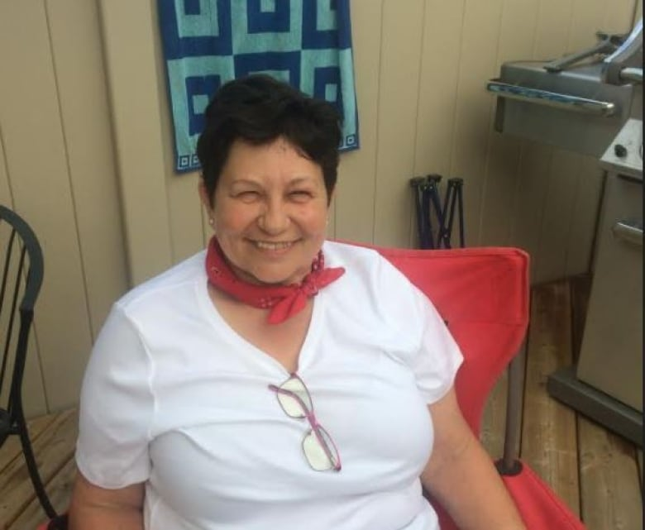
Ottawa resident Joy Malcolm has been reunited with her 1972 nursing grad class ring, thanks to teacher Evan Cappon. (Submitted by Joy Malcolm)
At the time, Malcolm scoured the school grounds and the route her son would have walked.
"Of course, we looked, but it's a pretty small ring, and it's a pretty big playground," she said.
When Malcolm found out her ring was going to be returned, she immediately emailed her son to let him in on the good news.
"I absolved him of guilt," she said. "I initially sent him an email saying, 'Do you remember when this happened?' And it was probably pretty traumatic, because he did. And I said, 'Well, guess what? It's found, you're free.'"
Will she ever let her son touch it again?
"I think I'll just leave it to him in my will," she said with a laugh.
Listen to the full interview on the Calgary Eyeopener here:
Calgary Eyeopener
Found ring
7:54
A lost ring has been reunited with its owner after it went missing in Calgary 37 years ago. 7:54

https://www.cbc.ca/news/canada/calgary/lost-ring-missing-for-37-years-has-been-reunited-with-its-owner-in-calgary-1.5739672

